Merge sort algorithm report
Parallel processing

Omar Amir
Karim Mansour
Omar Ahmed
Mostafa Rady
Seif saber
Yousef elbedewy

What is merge sort?
Merge Sort is a highly efficient, comparison-based sorting algorithm that employs the divide and conquer method.
Divide: the array is recursively divided till theres only a single element in the array and then it is sorted inherently.
Conquer: the inherently sorted array then is slowly merged with other array and sorted once again.
The function parses the elements one by one and sorting them till it fully combines the array.
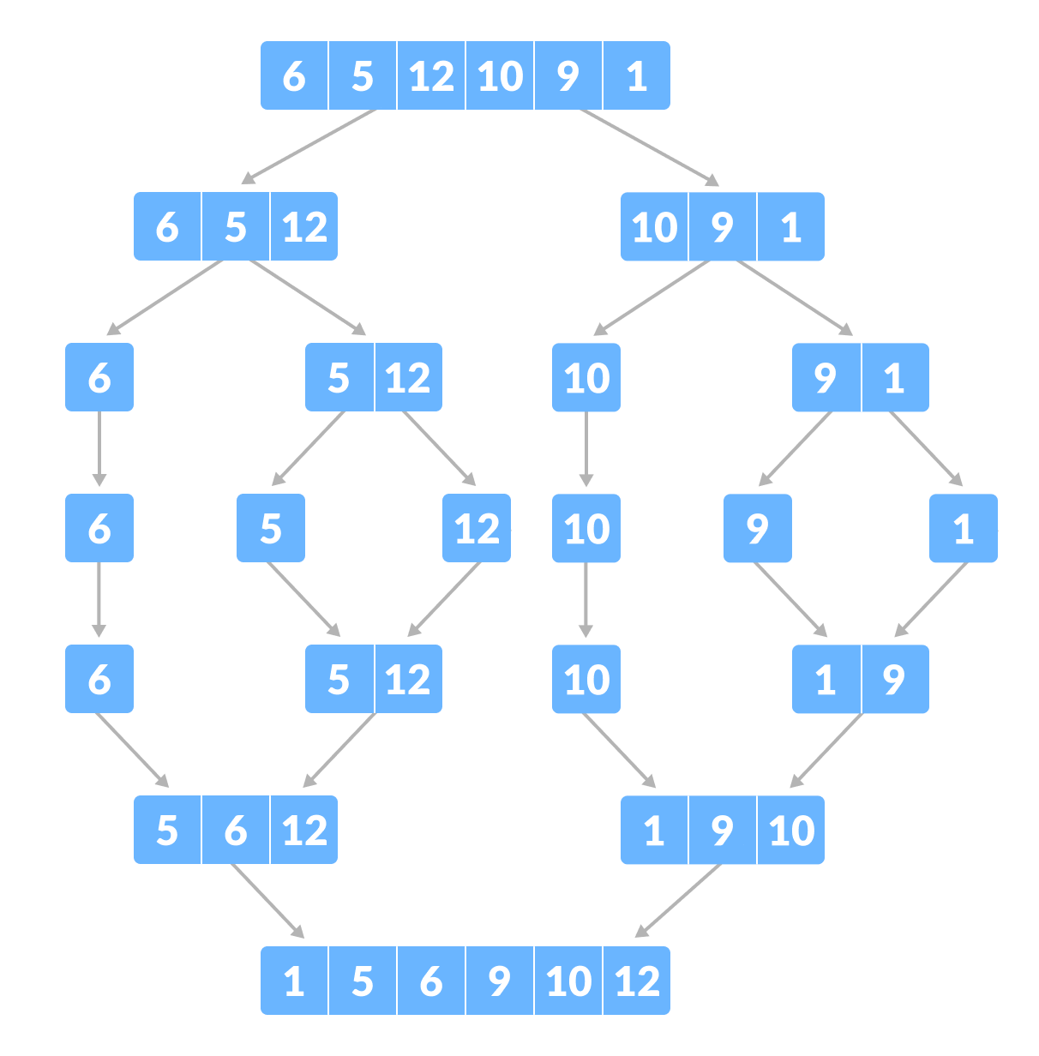

Description of our parallel merge design
Our parallel merge sort uses Java’s Fork/Join Framework to divide the sorting work into multiple tasks that run concurrently. The algorithm begins by creating a MergeSortTask, which represents a portion of the array to be sorted. If the segment size is large, the task is divided into two new tasks (left and right halves). These tasks are executed in parallel using invokeAll.
InvokeALL enables our divided array to work together using multiple cpu cores and makes both sides work in parallel. They also wait for each other to finish the both tasks before continuing to merge the sorted arrays.

Choice of Threshold
We chose to go for the size of 2000 after testing multiple different sizes (10k,100k,1million). We found that the size of 2000 is good to fit all these sizes were its not too big to cause overhead or too small to make the system slower.

Results regarding 2000 as threshold size
Speed up is calculated with the following formula:
speedup= sequential sort/parallel sort

Array Size: 10,000
Input Type | Sequential (ms) | Parallel (ms) | Speedup | Arrays.sort (ms)
Random | 1.71228 | 1.46492 | 1.17× | 1.48840
Reverse Sorted | 0.65282 | 1.13264 | 0.58× (slower) | 0.23630
Sorted | 0.58538 | 0.35826 | 1.63× | 0.17576

Array Size: 100,000
Input Type | Sequential (ms) | Parallel (ms) | Speedup | Arrays.sort (ms)
Random | 13.58834 | 3.62994 | 3.74× | 10.50318
Reverse Sorted | 7.33020 | 2.02968 | 3.61× | 0.11670
Sorted | 6.32136 | 2.08904 | 3.03× | 0.02532

Array Size: 1,000,000
Input Type | Sequential (ms) | Parallel (ms) | Speedup | Arrays.sort (ms)
Random | 147.55866 | 36.41430 | 4.05× | 82.40278
Reverse Sorted | 63.99466 | 19.19680 | 3.33× | 0.91828
Sorted | 68.12078 | 19.62432 | 3.47× | 0.26450

Analysis
After testing and trying it looks like parallel is slower with the smallest size (10000) due to creating overhead thus that’s why it is faster to just use sequential merge sort. As the array size grew, parallel merge sort as show at the size of 1 million the speed up was between 3-4 times faster depending on how the array was sorted. If the array keeps getting bigger it will prove to be even more efficient and possibly increasing the threshold size would make it even faster.

Arrays.sort proves to be faster in sorted and reverse sorted because it checks both sides of the array. This method is called dual pivot making reading the array is quicker and knowing that the array is sorted more efficiently than our sequential and parallel merge sorts.

